Project Design Phase
Solution Architecture

Date | 29 September 2026
Team ID | UNM111DJMRP
Project Name | AI FitTrack – AI-Powered Fitness Management and Recommendation System
Maximum Marks

Solution Architecture:
Solution architecture is a complex process – with many sub-processes – that bridges the gap between business problems and technology solutions. Its goals are to:
- Find the best tech solution to solve existing business problems.
- Describe the structure, characteristics, behavior, and other aspects of the software to project stakeholders.
- Define features, development phases, and solution requirements.
- Provide specifications according to which the solution is defined, managed, and delivered.

AI FitTrack – Solution Architecture Diagram:
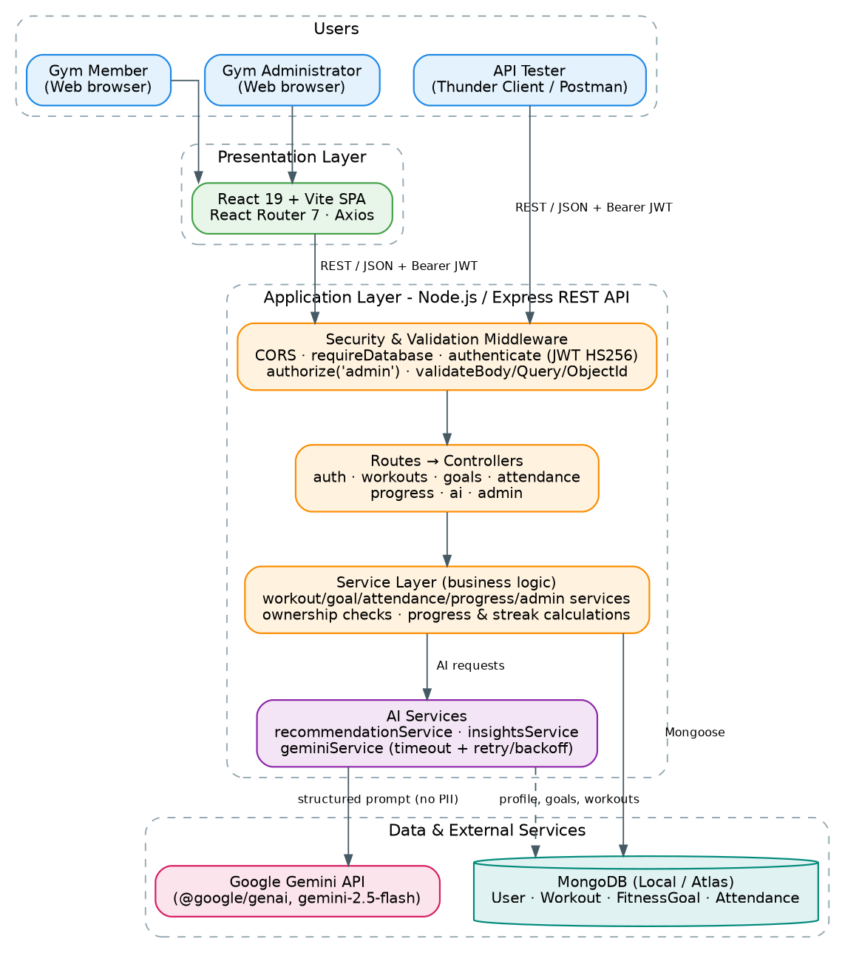
Figure 1: AI FitTrack solution architecture – users, React client, layered Express API (security, controllers, services, AI services), MongoDB and Google Gemini.

Reference: AI FitTrack Technical Documentation – Sections 5, 6 and 17 (source: server/ and client/).
How the solution works
• Presentation layer: a React 19 + Vite web app (or Thunder Client / Postman) sends JSON requests with a Bearer JWT.
• Security & validation: CORS allow-list, database-availability guard, JWT verification (HS256), role check for admin routes, declarative request validation.
• Business logic: thin controllers call services that enforce ownership, calculate goal progress, streaks, consistency and admin aggregations.
• AI layer: recommendation and insights services build structured prompts from the member's own data and call Gemini through one shared service with timeout and retry.
• Data layer: MongoDB collections User, Workout, FitnessGoal and Attendance accessed with Mongoose.

